**Table of Contents**

1. Show all customers whose creditLimit is greater than 20000 1

2. Show the employees who report to VP Sales 1

3. Find all customers who have set their state, live in USA, and credit limit is between 100000 and 200000 2

4. Find all employees who report to Sales Managers of all types 2

5. Find the average credit limit of customers of each country 3

6. Find total orders for each date and customer (only dates with >10 orders) 3

7. Find supervisor info and supervisee count using subquery (without JOIN) 4

8. Find supervisor info and supervisee count using JOIN 4

9. Find customers with credit limit greater than average using WITH clause 5

10. Find customer rank by credit limit and get 3rd highest 6

11. Generate report showing total employees in each office 7

12. Generate report showing total customers visited each office 8

13. Generate report showing total payment received by each office 9

14. Generate report showing total sales by each office 10

15. Generate report showing total payment pending for each office 11

16. Find creditLimit proportion of each person in each country 12

17. Create a view showing customer name, complete address, and total orders 13

18. Update the country of a customer 14

19. Delete all payments below 20,000 15

20. Add new payments manually for an existing customer 16

SQL Assignment Solutions - Classic Models Database (Query Solutions)

# 1. Show all customers whose creditLimit is greater than 20000

SELECT *

FROM customers

WHERE creditLimit > 20000;

Figure 1 Q1

# 2. Show the employees who report to VP Sales

SELECT e.*

FROM employees e

JOIN employees m ON e.reportsTo = m.employeeNumber

WHERE m.jobTitle = 'VP Sales';

Figure 2 Q2

# 3. Find all customers who have set their state, live in USA, and credit limit is between 100000 and 200000

SELECT *

FROM customers

WHERE state IS NOT NULL

AND country = 'USA'

AND creditLimit BETWEEN 100000 AND 200000;

Figure 3 Q3

# 4. Find all employees who report to Sales Managers of all types

SELECT e.*

FROM employees e

JOIN employees m ON e.reportsTo = m.employeeNumber

WHERE m.jobTitle LIKE '%Sales Manager%';

Figure 4 Q4

# 5. Find the average credit limit of customers of each country

SELECT country, AVG(creditLimit) as average_credit_limit

FROM customers

GROUP BY country

ORDER BY average_credit_limit DESC;



Figure 5 Q5

# 6. Find total orders for each date and customer (only dates with >10 orders)

SELECT orderDate, customerNumber, COUNT(*) as total_orders

FROM orders

GROUP BY orderDate, customerNumber

HAVING COUNT(*) > 10

ORDER BY orderDate, total_orders DESC;



Figure 6 Q6

# 7. Find supervisor info and supervisee count using subquery (without JOIN)

SELECT

employeeNumber,

CONCAT(firstName, ' ', lastName) as supervisor_name,

jobTitle as supervisor_job_title,

(SELECT COUNT(*)

FROM employees e2

WHERE e2.reportsTo = e1.employeeNumber) as total_supervisees

FROM employees e1

WHERE employeeNumber IN (SELECT DISTINCT reportsTo FROM employees WHERE reportsTo IS NOT NULL)

ORDER BY total_supervisees DESC;

Figure 7 Q7

# 8. Find supervisor info and supervisee count using JOIN

SELECT

m.employeeNumber,

CONCAT(m.firstName, ' ', m.lastName) as supervisor_name,

m.jobTitle as supervisor_job_title,

COUNT(e.employeeNumber) as total_supervisees

FROM employees m

JOIN employees e ON m.employeeNumber = e.reportsTo

GROUP BY m.employeeNumber, m.firstName, m.lastName, m.jobTitle

ORDER BY total_supervisees DESC;

Figure 8 Q8

# 9. Find customers with credit limit greater than average using WITH clause

WITH avg_credit AS (

SELECT AVG(creditLimit) as avg_limit

FROM customers

)

SELECT c.*

FROM customers c, avg_credit

WHERE c.creditLimit > avg_credit.avg_limit

ORDER BY c.creditLimit DESC;

Figure 9 Q9

# 10. Find customer rank by credit limit and get 3rd highest

-- Customer rankings

SELECT

customerNumber,

customerName,

creditLimit,

RANK() OVER (ORDER BY creditLimit DESC) as credit_rank

FROM customers

ORDER BY creditLimit DESC;

-- Customer with 3rd highest credit limit

SELECT

customerNumber,

customerName,

creditLimit

FROM (

SELECT

customerNumber,

customerName,

creditLimit,

RANK() OVER (ORDER BY creditLimit DESC) as credit_rank

FROM customers

) ranked_customers

WHERE credit_rank = 3;

Figure 10 Q10

# 11. Generate report showing total employees in each office

SELECT

o.officeCode,

o.city,

o.state,

o.country,

COUNT(e.employeeNumber) as total_employees

FROM offices o

LEFT JOIN employees e ON o.officeCode = e.officeCode

GROUP BY o.officeCode, o.city, o.state, o.country

ORDER BY total_employees DESC;

Figure 11 Q11

# 12. Generate report showing total customers visited each office

SELECT

o.officeCode,

o.city,

o.state,

o.country,

COUNT(DISTINCT c.customerNumber) as total_customers

FROM offices o

LEFT JOIN employees e ON o.officeCode = e.officeCode

LEFT JOIN customers c ON e.employeeNumber = c.salesRepEmployeeNumber

GROUP BY o.officeCode, o.city, o.state, o.country

ORDER BY total_customers DESC;

Figure 12 Q12

# 13. Generate report showing total payment received by each office

SELECT

o.officeCode,

o.city,

o.state,

o.country,

COALESCE(SUM(p.amount), 0) as total_payments

FROM offices o

LEFT JOIN employees e ON o.officeCode = e.officeCode

LEFT JOIN customers c ON e.employeeNumber = c.salesRepEmployeeNumber

LEFT JOIN payments p ON c.customerNumber = p.customerNumber

GROUP BY o.officeCode, o.city, o.state, o.country

ORDER BY total_payments DESC;

Figure 13 Q13

# 14. Generate report showing total sales by each office

SELECT

o.officeCode,

o.city,

o.state,

o.country,

COALESCE(SUM(od.quantityOrdered * od.priceEach), 0) as total_sales

FROM offices o

LEFT JOIN employees e ON o.officeCode = e.officeCode

LEFT JOIN customers c ON e.employeeNumber = c.salesRepEmployeeNumber

LEFT JOIN orders ord ON c.customerNumber = ord.customerNumber

LEFT JOIN orderdetails od ON ord.orderNumber = od.orderNumber

GROUP BY o.officeCode, o.city, o.state, o.country

ORDER BY total_sales DESC;

Figure 14 Q14

# 15. Generate report showing total payment pending for each office

SELECT

o.officeCode,

o.city,

o.state,

o.country,

COALESCE(SUM(od.quantityOrdered * od.priceEach), 0) - COALESCE(SUM(p.amount), 0) as payment_pending

FROM offices o

LEFT JOIN employees e ON o.officeCode = e.officeCode

LEFT JOIN customers c ON e.employeeNumber = c.salesRepEmployeeNumber

LEFT JOIN orders ord ON c.customerNumber = ord.customerNumber

LEFT JOIN orderdetails od ON ord.orderNumber = od.orderNumber

LEFT JOIN payments p ON c.customerNumber = p.customerNumber

GROUP BY o.officeCode, o.city, o.state, o.country

ORDER BY payment_pending DESC;

Figure 15 Q15

# 16. Find creditLimit proportion of each person in each country

SELECT

customerNumber,

customerName,

country,

creditLimit,

SUM(creditLimit) OVER (PARTITION BY country) as country_total_credit,

ROUND(creditLimit / SUM(creditLimit) OVER (PARTITION BY country) * 100, 2) as credit_proportion_percentage

FROM customers

ORDER BY country, credit_proportion_percentage DESC;

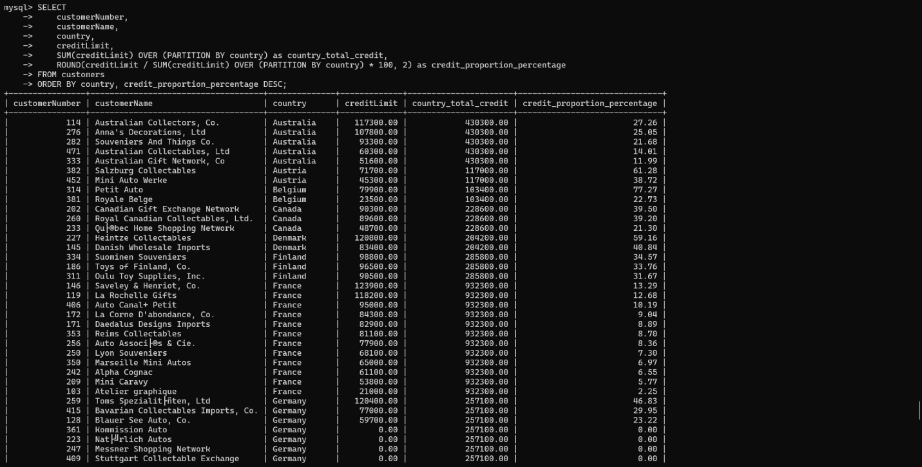

Figure 16 Q16

# 17. Create a view showing customer name, complete address, and total orders

CREATE VIEW customer_order_summary AS

SELECT

c.customerNumber,

c.customerName,

CONCAT(c.addressLine1,

CASE WHEN c.addressLine2 IS NOT NULL THEN CONCAT(', ', c.addressLine2) ELSE '' END,

', ', c.city,

CASE WHEN c.state IS NOT NULL THEN CONCAT(', ', c.state) ELSE '' END,

', ', c.postalCode,

', ', c.country) as complete_address,

COUNT(o.orderNumber) as total_orders

FROM customers c

LEFT JOIN orders o ON c.customerNumber = o.customerNumber

GROUP BY c.customerNumber, c.customerName, complete_address

ORDER BY total_orders DESC;

-- To view the created view:

SELECT * FROM customer_order_summary;

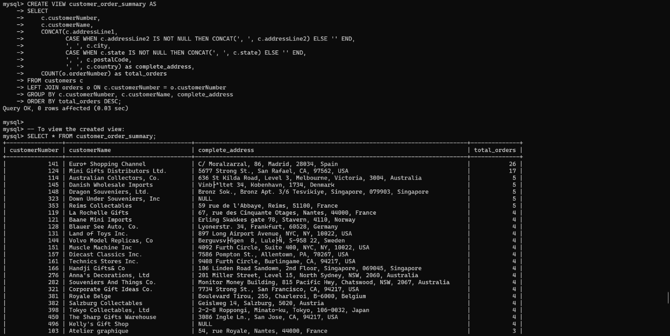

Figure 17 Q17

# 18. Update the country of a customer

-- First, check current data

SELECT customerNumber, customerName, country

FROM customers

WHERE customerNumber = 103;

-- Update the country

UPDATE customers

SET country = 'Canada'

WHERE customerNumber = 103;

-- Verify the update

SELECT customerNumber, customerName, country

FROM customers

WHERE customerNumber = 103;

Figure 18 Q18

# 19. Delete all payments below 20,000

-- First, check how many payments will be affected

SELECT COUNT(*) as payments_to_delete

FROM payments

WHERE amount < 20000;

-- Delete payments below 20,000

DELETE FROM payments

WHERE amount < 20000;

-- Verify deletion

SELECT COUNT(*) as remaining_payments

FROM payments;

Figure 19 Q19

# 20. Add new payments manually for an existing customer

-- Check existing customer

SELECT customerNumber, customerName

FROM customers

WHERE customerNumber = 103;

-- Insert new payment

INSERT INTO payments (customerNumber, checkNumber, paymentDate, amount)

VALUES (103, 'CHK001', '2024-01-15', 25000.00);

-- Insert another payment

INSERT INTO payments (customerNumber, checkNumber, paymentDate, amount)

VALUES (103, 'CHK002', '2024-02-15', 30000.00);

-- Verify the new payments

SELECT * FROM payments

WHERE customerNumber = 103

ORDER BY paymentDate DESC;

Figure 20 Q20